## Complete data log likelihood of the model

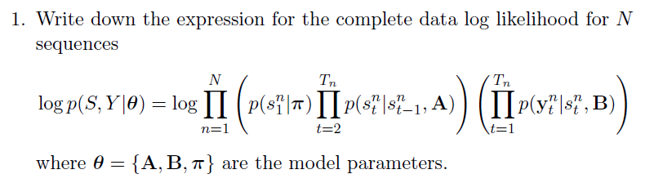

Having N realizations of the HMMs $\left\{Y^{n},S^{n}\right\}$, with $Y=\left\{Y^{1},Y^{2},…,Y^{N}\right\}$, $S=\left\{S^{1},S^{2},…,S^{N}\right\}$ each realization has T time index elements, $Y^{n}={\overline{y}}_{1:T}^{n}= \left\{{\overline{y}}_{1}^{n},{\overline{y}}_{2}^{n},…,{\overline{y}}_{T}^{n}\right\}$**, $S^{n}=s_{1:T }^{n}=\left\{s_{1}^{n},s_{2}^{n},…,s_{1}^{n}\right\}$** .

We can obtain the complete data log likelihood of one of these realizations $\left\{Y^{n},S^{n}\right\}$ as:

$$\ln\left(I_{C}\left(θ\right)\right)=\ln\left(p\left(Y,S | θ\right)\right)=\ln\left(\underset{p\left(S | \overline{θ}\right)}{\underbrace{\left(p\left(s_{1} | θ\right)\prod_{t=2}^{T}{p\left(s_{t} | s_{t-1},A\right)}\right)}}·\underset{p\left(Y | S,\overline{θ}\right)}{\underbrace{\left(\prod_{t=1}^{T}{p\left({\overline{y}}_{t} | s_{t},B\right)}\right)}}\right)$$

For a group N realizations of the HMM we have, that the complete log likelihood of $\left\{Y,S\right\}$ is:

$$I_{C}\left(\overline{θ}\right)=\ln\left(p\left(Y,S | \overline{θ}\right)\right)=\sum_{n=1}^{N}{\ln\left(p\left(Y=Y^{n},S | θ\right)\right)}==\sum_{n=1}^{N}{\sum_{i=1}^{I}{I\left(s_{1}^{n}=i\right)\underset{\ln\left(π_{i}\right)}{\underbrace{\ln\left(p\left(s_{1}^{n}=i | θ\right)\right)}}}} +\sum_{n=1}^{N}{\sum_{t=2}^{T}{\left(\sum_{i=1}^{I}{\sum_{j=1}^{I}{I\left(s_{t}^{n}=j,s_{t-1}^{n}=i \right)\underset{\ln\left(a_{ij}\right)}{\underbrace{\ln\left(p\left(s_{t}^{n}=j | s_{t-1}^{n}=i,A\right)\right)}}}}\right)}}+\sum_{n=1}^{N}{\sum_{t=1}^{T}{\left(\sum_{i=1}^{I}{I\left(s_{t}^{n}=i\right)\underset{\ln\left(p_{i}\left({\overline{y}}_{t}^{n}| {\overline{b}}_{i}\right)\right)}{\underbrace{\ln\left(p\left({\overline{y}}_{t}={\overline{y}}_{t}^{n} | s_{t}^{n}=i,B\right)\right)}}}\right)}}$$

We finally obtain:

$$I_{C}\left(θ\right)=\sum_{i=1}^{I}{\left(\sum_{n=1}^{N}{I\left(s_{1}^{n}=i\right)\ln\left(π_{i}\right)}\right)} + \sum_{i=1}^{I}{\sum_{j=1}^{I}{\left(\sum_{n=1}^{N}{\sum_{t=2}^{T}{I\left(s_{t}^{n}=j,s_{t-1}^{n}=i \right)\ln\left(a_{ij}\right)}}\right)}}+\sum_{i=1}^{I}{\left(\sum_{n=1}^{N}{\sum_{t=1}^{T}{I\left(s_{t}^{n}=i\right)\ln\left(p_{i}\left({\overline{y}}_{t}^{n} | {\overline{b}}_{i}\right)\right)}}\right)}$$

## Expected complete data log likelihood of the model

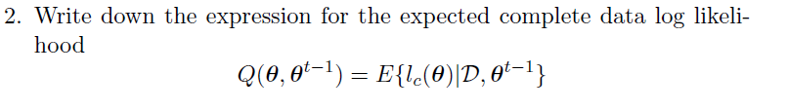

We know:

$$Q\left(θ,θ^{r-1}\right)=E\left\{I_{C}\left(θ\right) | Y,θ^{r-1}\right\}=\sum_{i=1}^{I}{\left(\sum_{n=1}^{N}{γ_{1}^{n}\left(i\right)}\ln\left(π_{i}\right)\right)} + \sum_{i=1}^{I}{\sum_{j=1}^{I}{\left(\sum_{n=1}^{N}{\sum_{t=2}^{T}{ξ_{t-1}^{n}\left(i,j\right)\ln\left(a_{ij}\right)}}\right)}}+\sum_{i=1}^{I}{\left(\sum_{n=1}^{N}{\sum_{t=1}^{T}{γ_{t}^{n}\left(i\right)\ln\left(p_{i}\left({\overline{y}}_{t}^{n} | {\overline{b}}_{i}\right)\right)}}\right)}$$

Where:

$$γ_{1}^{n}\left(i\right)= P\left(s_{1}^{n}=i|Y, θ^{r-1}\right)$$

$$γ_{t}^{n}\left(i\right)=P\left(s_{t}^{n}=i|Y, θ^{r-1}\right)$$

$$ξ_{t-1}^{n}\left(i,j\right)= P\left(s_{t}^{n}=j,s_{t-1}^{n}=i|Y, {\overline{θ}}^{r-1}\right)$$

Where:

$$γ_{t}^{n}\left(i\right) ∝ α_{t}^{n}\left(i\right)·β_{t}^{n}\left(i\right)$$

$$ξ_{t}^{n}\left(i,j\right) ∝ α_{t}^{n}\left(i\right)a_{ij}p_{j}\left({\overline{y}}_{t+1}^{n} | {\overline{b}}_{j}\right)·β_{t+1}^{n}\left(j\right)$$

Normalize using the properties:

$$\sum_{j=1}^{I}{γ_{t}^{n}\left(i\right)}=1 and \sum_{i=1}^{I}{\sum_{j=1}^{I}{ξ_{t}^{n}\left(i,j\right)}}=1$$

The alphas and betas are obtained as:

Formula for the alphas:

$$α_{1}^{n}\left(i\right)=π_{i}·p_{i}\left({\overline{y}}_{1}^{n}| {\overline{b}}_{i}\right) i=1,…, I n=1,…,N$$

$$α_{t}^{n}\left(i\right)=p_{i}\left({\overline{y}}_{t}^{n}| {\overline{b}}_{i}\right)\sum_{j=1}^{ I}{ a_{ji}α_{t-i}^{n}\left(j\right)} i=1,…, I t=2,…,T n=1,…,N$$

Formula for the betas:

$$β_{T}^{n}\left(i\right)=1 i=1,…, I n=1,…,N$$

$$β_{t}^{n}\left(i\right)=\sum_{j=1}^{ I}{ a_{ij}·p_{j}\left({\overline{y}}_{t}^{n}| {\overline{b}}_{j}\right)·β_{t+1}^{n}\left(j\right)} i=1,…, I t=1,…,T-1 n=1,…,N$$

## Expression for the ML estimates

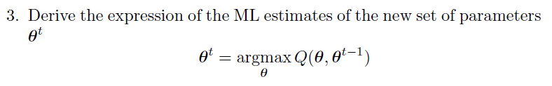

We know:

$$Q\left(θ,θ^{r-1}\right)=\underset{Depends on \overline{π}}{\underbrace{\sum_{i=1}^{I}{\left(\sum_{n=1}^{N}{γ_{1}^{n}\left(i\right)}\ln\left(π_{i}\right)\right)}}} + \underset{Depends on A}{\underbrace{\sum_{i=1}^{I}{\sum_{j=1}^{I}{\left(\sum_{n=1}^{N}{\sum_{t=2}^{T}{ξ_{t-1}^{n}\left(i,j\right)\ln\left(a_{ij}\right)}}\right)}}}}+\underset{Depends on B}{\underbrace{\sum_{i=1}^{I}{\left(\sum_{n=1}^{N}{\sum_{t=1}^{T}{γ_{t}^{n}\left(i\right)\ln\left(p_{i}\left({\overline{y}}_{t}^{n} | b_{i}\right)\right)}}\right)}}}$$

Taking the derivative and equaling to 0, we get:

* **Probabilities of the initial state $\overline{π}$**

We have that:

$$π_{i}=\frac{N_{i}}{N}=\frac{1}{N}\sum_{n=1}^{N}{γ_{1}^{n}\left(i\right)} N=\sum_{i=1}^{I}{N_{i}}$$

* **Transition probabilities $A$**

We have that:

$$a_{ij}=\frac{E_{ij}}{E_{i}}=\frac{1}{E}\sum_{n=1}^{N}{\sum_{t=2}^{T}{ξ_{t-1}^{n}\left(i,j\right)}} E_{i}= \sum_{j=1}^{I}{\sum_{n=1}^{N}{\sum_{t=2}^{T}{ξ_{t-1}^{n}\left(i,j\right)}}}$$

* **Values of the parameters of the random distributions b**

Since the observation emission probabilities $P_{i}\left(\overline{y}|{\overline{b}}_{i}\right)$, follow a D-dimensional multinomial, we use the property of moment matching for the exponential family and we have:

$$E\left\{ϕ\left({\overline{Y}}_{i}\right)\right\}=\frac{1}{{Γ_{i}}_{i}}\sum_{n=1}^{N}{\sum_{t=1}^{T}{γ_{t}^{n}\left(i\right)\left(ϕ\left({\overline{y}}_{t}^{n}\right)\right)}} with Γ_{i}=\sum_{n=1}^{N}{\sum_{t=1}^{T}{γ_{t}^{n}\left(i\right)}}$$

The $d-th$ component of the $i-th$ state is:

$$b_{id}=\frac{1}{ Γ_{i}}\sum_{n=1}^{N}{\sum_{t=1}^{T}{γ_{t}^{n}\left(i\right)\left(y_{td}^{n}\right)}}$$